Deliverable D2

# Purpose and scope

Define what is the goal of the system, what problems tries to solve. Be clear and explicit about the boundaries of the system (what is IN, what is OUT).

This information is similar to the Vision, but here it should be more concise, formal and precise.

Length: max 2-3 paragraphs

# Definitions

## Glossary

Define the terms, the conventions, the concepts that you will use in your system specification. In this section you define the *meaning* of the words that you will user later in the requirements, in order to wipe out any ambiguity. For example, “the interface” is a very general term, but in the glossary you may define “Interface = web application used to access the schedule from a PC or smartphone”.

## Actors

In particular, you must define the ACTORS of the system, i.e., all the types of users that will directly interact with the system. Be specific (i.e., teacher giving a class, or student seeking a study room, not generically ‘teacher’ or ‘student’).

# System Requirements

## Functional Requirements

You may find useful to group the requirements according to “Functional Areas”, i.e., related groups of functionalities that are related to a portion of the system features.

For example:

|  |  |
| --- | --- |
| Functional Area | Description |
| 1 | User login, registration and logout |
| 2 | Public web pages visible by any user (even not registered users) |
| 3 | Notifications sent by the system to user devices |
| 4 | Interface for setting user preferences |
| 5 | … etc etc … |

You may then group and list functional requisites according to their functional area, by using a numeric code X.Y (X=area, Y=requisite within the area).

The template for each requisite should contain the following informations:

* FR X.Y: Title
  + Description (verifiable)
  + Priority: 1--5

## Non-Functional Requirements

* NFR Z: Title
  + Description
  + Area (select one item from the picture below)

The most important areas to consider in our prototypes/projects are: Portability (list all the compatible devices), Interoperability (which external systems are involved), Efficiency (mention the expected response times).

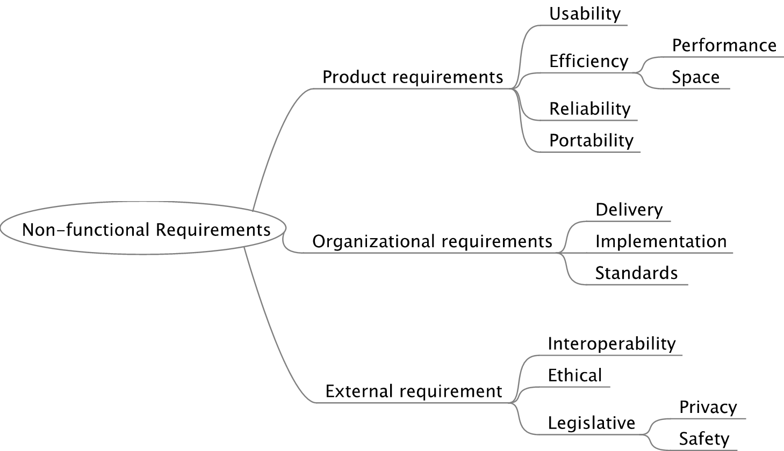

# Open issues

Continuation of the open issues in D1.